INFOSYS SPRINGBOARD
VIRTUAL INTERNSHIP 7.0
SUPPLY CHAIN VISIBILITY AND OPTIMIZATION
Milestone-4 Report
SUBMITTED BY
POCHURU SUPRAJA
Power BI – Supply Chain Analytics Project

Table of Contents
1. Milestone 4 Overview
2. Topic 1 – Warehouse Efficiency Reports
3. Topic 2 – Executive Overview Dashboard
4. Topic 3 – Optimized Dashboard Performance
5. Topic 4 – Final Testing, Documentation and Deployment
6. Overall Business Insights
7. Conclusion

1. Milestone 4 Overview
The project title is Supply Chain Visibility and Optimization. Milestone 4 is the reporting and final delivery stage of the project. The purpose of this milestone is to convert the prepared supply-chain data into an interactive Power BI solution that improves visibility into warehouse operations and supports data-driven optimization.
The work in this milestone is organized into four topics. The first topic develops warehouse efficiency reports. The second creates an executive overview dashboard. The third focuses on optimizing dashboard performance and usability. The fourth covers final testing, documentation and deployment of the completed solution.

2. Topic 1 – Warehouse Efficiency Reports
The Warehouse Efficiency Reports provide detailed visibility into inventory and warehouse operations. The report combines key performance indicators with location-based visualizations so that warehouse performance can be compared and areas requiring improvement can be identified.

2.1 Key Performance Indicators
KPI | Displayed Value | Purpose
Inventory Value | 1.34M | Shows the monetary value of inventory.
Total Inventory | 26.23K | Shows the quantity of inventory available.
Inventory Turnover | 12.08 | Indicates the movement/replacement of inventory.
Fulfillment Rate | 92.35% | Shows the level of successful order fulfillment.
Total Orders | 623 | Shows overall order activity.
On-Time Delivery | 44.94% | Measures delivery timeliness and highlights an improvement area.

2.2 Warehouse Efficiency Analysis
- Total Inventory by Location compares inventory held by Kolkata, Mumbai, Chennai, Bangalore and Delhi. Kolkata has the highest displayed inventory level.
- Sum of Defect Rates by Location helps identify locations with higher defect-related values. Kolkata has the highest displayed value and Delhi the lowest.
- The Warehouse Efficiency and Target Efficiency gauge shows current efficiency around 75.68 against a target of about 90, indicating a performance gap.
- Revenue by Location shows Kolkata with the largest displayed revenue contribution at about 34.84%, followed by Chennai, Mumbai, Bangalore and Delhi.
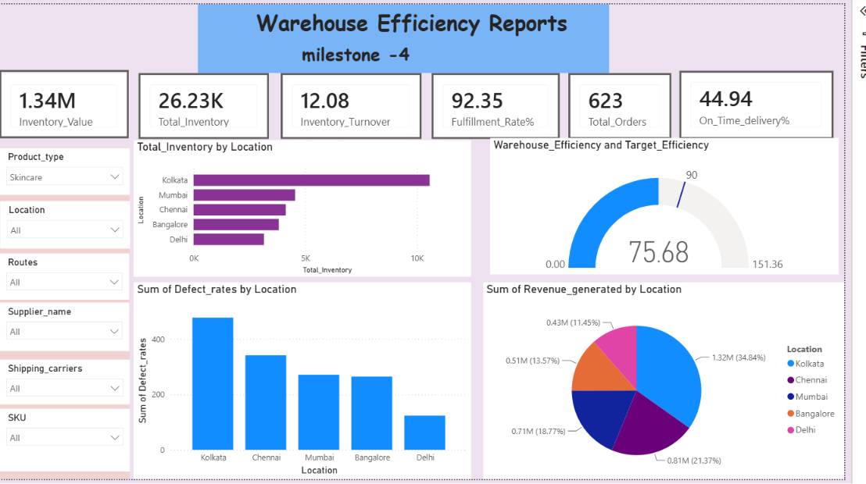
Figure 1. 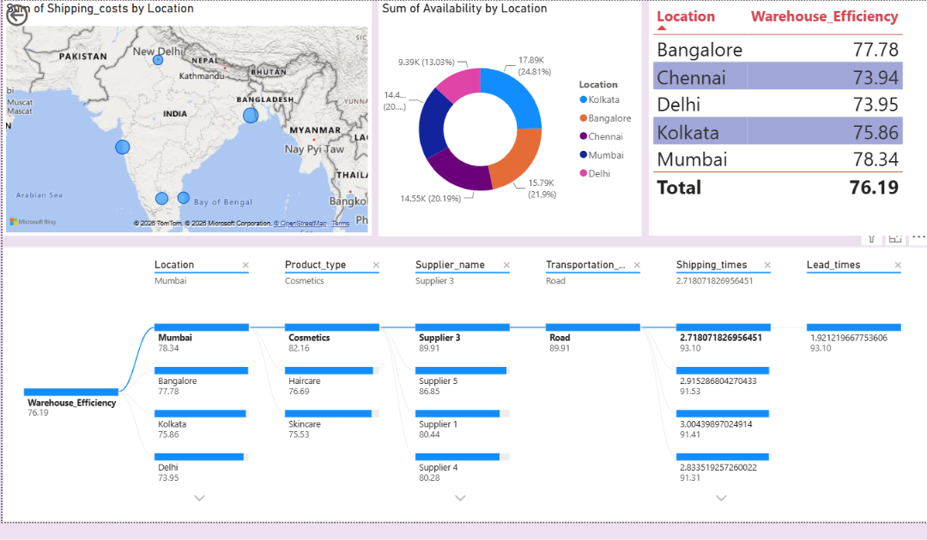page2-Warehouse Efficiency Reports

3. Topic 2 – Executive Overview Dashboard
The Executive Overview Dashboard is designed for managers and decision-makers who need a quick understanding of the current supply-chain situation. Instead of examining individual records, management can start with the KPI cards and then use the supporting visuals for comparison and investigation.

3.1 Dashboard Components
- KPI cards provide an immediate summary of inventory value, inventory quantity, turnover, fulfillment, orders and on-time delivery.
- Location charts compare inventory and defect-related performance across warehouses.
- The gauge highlights the difference between current warehouse efficiency and the target.
- The revenue pie chart shows the contribution of each warehouse location.
- Slicers allow users to filter the dashboard by Product Type, Location, Routes, Supplier Name, Shipping Carriers and SKU.
- The dashboard is structured so that high-level information appears first and detailed analysis can be performed afterward.

3.2 Location-wise Executive View
Location | Warehouse Efficiency
Mumbai | 78.34
Bangalore | 77.78
Kolkata | 75.86
Delhi | 73.95
Chennai | 73.94
Total | 76.19
Mumbai has the highest displayed warehouse efficiency at 78.34, followed by Bangalore at 77.78. Chennai and Delhi are the lowest-performing locations in the displayed table. This helps management prioritize locations for operational review.

3.2 Decomposition Tree for Decision Support
The Decomposition Tree starts with overall Warehouse Efficiency and allows the user to drill down through Location, Product Type, Supplier Name, Transportation, Shipping Time and Lead Time. It provides a structured way to investigate why efficiency differs across parts of the supply chain.

4. Topic 3 – Optimized Dashboard Performance
Dashboard optimization was treated as an important part of the final reporting stage. The aim is not only to make the dashboard visually attractive, but also to make it fast, focused, readable and useful for decision-making.
Optimization Area | Approach
Focused visual design | Keep only visuals that directly support supply-chain decisions and remove repetitive visuals.
Reusable DAX measures | Use measures for KPIs so calculations are consistent and can be reused across visuals.
Efficient slicers | Use relevant filters without overcrowding the report page.
Consistent formatting | Maintain consistent titles, units, decimal places, spacing and alignment.
Drill-down analysis | Use the Decomposition Tree for detailed investigation instead of adding too many separate charts.
Performance checking | Use Power BI Performance Analyzer to identify visuals or queries that require optimization.
Clear navigation | Arrange the report logically so users can move from executive KPIs to detailed analysis.

4.1 Expected Benefits of Optimization
- Faster and smoother interaction with the dashboard.
- Less visual clutter and easier interpretation of important KPIs.
- Consistent calculations across report pages.
- Better user experience when filtering by location, product, supplier or SKU.
- Improved maintainability when the dataset or reporting requirements change.
5. Topic 4 – Final Testing, Documentation and Deployment
The fourth topic completes the project by validating the dashboard, documenting its functionality and preparing it for deployment. These activities ensure that the final report is reliable, understandable and ready for intended users.

5.1 Final Testing
Test Area | What is Checked | Expected Result
Data validation | Fields, types, totals and loaded records | Values match the prepared dataset
KPI validation | Inventory, turnover, fulfillment, orders and delivery calculations | Measures return expected values
Slicer testing | Product Type, Location, Routes, Supplier, Carrier and SKU | Selected filters update visuals
Visual interaction | Cross-filtering and selections | Related visuals respond correctly
Gauge validation | Current efficiency and target | Target comparison is displayed correctly
Decomposition Tree | Each drill-down level | Branches show meaningful values
Formatting | Titles, labels, units and alignment | Dashboard is clear and readable
Performance | Visual loading/query behavior | No unnecessary slow visuals
Final review | Overall presentation and usability | Report is ready for delivery

5.2 Documentation
Documentation provides a reference for understanding and maintaining the dashboard. It records the purpose of the report, the major KPIs, available filters, visual interpretation and the intended use of the Decomposition Tree.
- Project title: Supply Chain Visibility and Optimization.
- Reporting platform: Microsoft Power BI.
- Primary dimensions: Location, Product Type, Supplier Name, Routes/Transportation, Shipping Carriers and SKU.
- Primary KPIs: Inventory Value, Total Inventory, Inventory Turnover, Fulfillment Rate, Total Orders and On-Time Delivery.
- Primary analytical visuals: KPI cards, bar charts, gauge, pie/donut charts, map, table and Decomposition Tree.

5.3 Deployment
After successful testing, the final Power BI report can be published to the designated Power BI workspace. Deployment includes validating the published report, configuring refresh when applicable and providing access to authorized users.
- Save the final Power BI report with a clear version name.
- Publish the validated report to the appropriate Power BI workspace.
- Configure data refresh according to the source-data requirements.
- Set appropriate viewer or contributor permissions.
- Open the published report and verify filters, visuals, navigation and drill-down functionality.
- Maintain version history for future improvements.

6. Overall Business Insights
The completed Supply Chain Visibility and Optimization dashboard provides several useful management insights:
- The dashboard records approximately 26.23K inventory units with an inventory value of about 1.34M.
- Fulfillment performance is 92.35%, showing a high level of successful fulfillment in the displayed data.
- On-time delivery is 44.94%, making delivery timeliness an important improvement area.
- The displayed warehouse efficiency is around 75.68 against a target of about 90, showing a clear efficiency gap.
- Mumbai has the highest location-wise warehouse efficiency at 78.34, while Chennai is the lowest at 73.94 in the displayed table.
- Kolkata has the highest displayed inventory and revenue contribution, so its inventory utilization and operational performance deserve particular attention.
- The Decomposition Tree allows management to move from an overall efficiency value to detailed supply-chain factors such as location, product type, supplier, transportation, shipping time and lead time.

7. Conclusion
Milestone 4 completes the reporting and delivery phase of the Supply Chain Visibility and Optimization project. The work has been organized into four topics: Warehouse Efficiency Reports, Executive Overview Dashboard, Optimized Dashboard Performance, and Final Testing, Documentation and Deployment.
The final Power BI solution provides both a high-level executive view and detailed analytical capabilities. It helps users monitor inventory, fulfillment, delivery, revenue and warehouse efficiency while using interactive filters and drill-down analysis to identify areas for optimization.
Overall, the dashboard transforms supply-chain data into actionable information and provides a foundation for better warehouse monitoring, operational improvement and data-driven decision-making.
END OF MILESTONE – 4 REPORT

